

SYMBIOSIS INTERNATIONAL (DEEMED UNIVERSITY)
(Established under section 3 of the UGC Act 1956)
Re-accredited by NAAC with “A” Grade

Name of the Student: Sneha Sah PRN: 25070122189
Semester: 3 Year: AY 25-29

ASSIGNMENT No: 8

TITLE:
Write a Java program to demonstrate the use of the super keyword in inheritance.
Problem Statement :
Write a Java program to demonstrate the use of the super keyword in inheritance.

Theory:
The super keyword in Java is used to refer to the immediate parent class. It is mainly used in inheritance to access parent class constructors, variables, and methods. It helps avoid confusion when both parent and child classes have members with the same name. The super keyword also ensures proper constructor execution during object creation. It is an important concept for understanding inheritance and method overriding in Java.

Exercise 1
To create an Employee and Manager program where the Manager class accesses Employee details using the super keyword.
Source code:
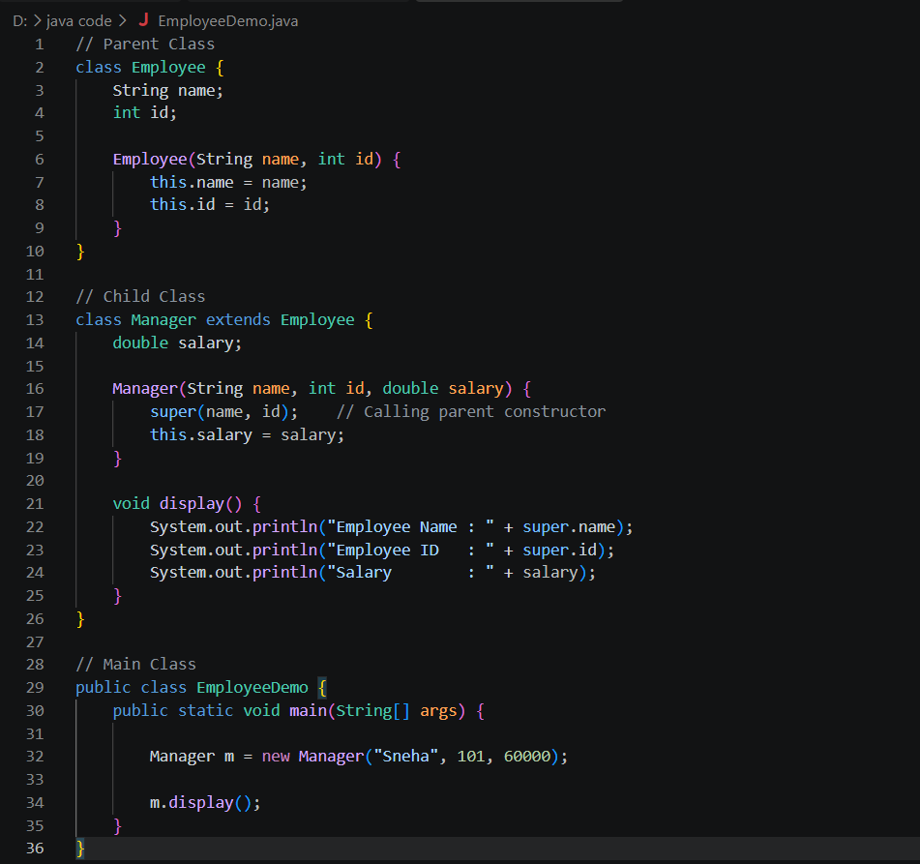
Output:
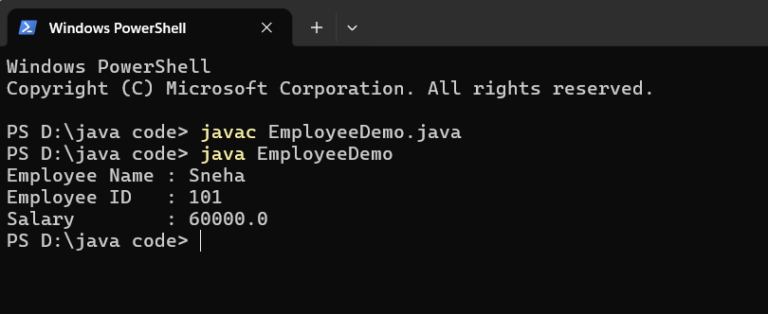

Exercise 2
To develop a Vehicle Insurance System where child insurance classes access parent vehicle information using the super keyword.
Source code:
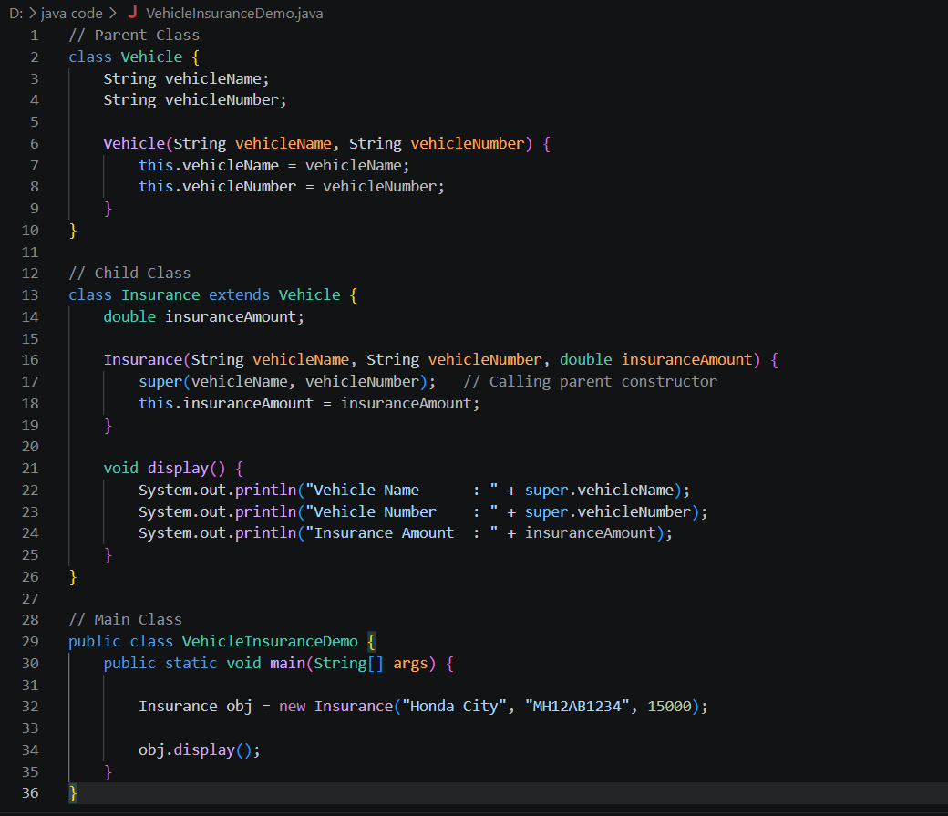

Output:
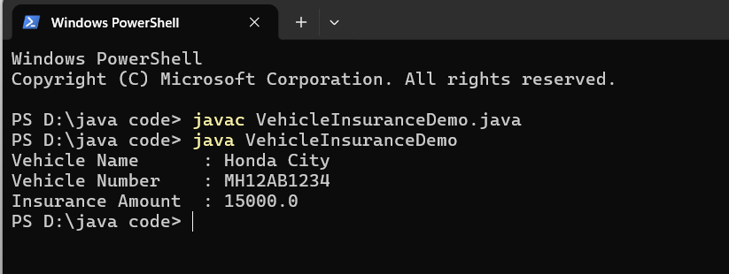

Conclusion
This assignment helped me understand the use of the super keyword in Java inheritance. I learned how to use super to call the parent class constructor and access parent class variables. Through the Employee–Manager and Vehicle Insurance System examples, I gained practical knowledge of inheritance, constructor chaining, and code reusability in Java.

